**To check if a string is palindrome or not**

**Code:**

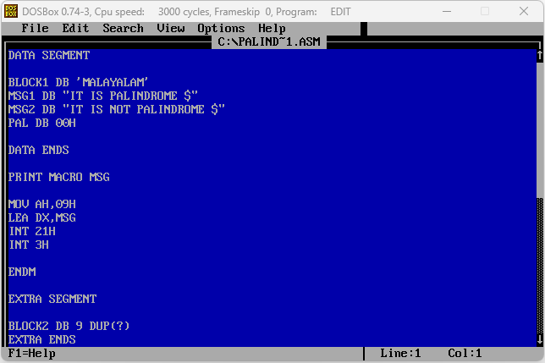

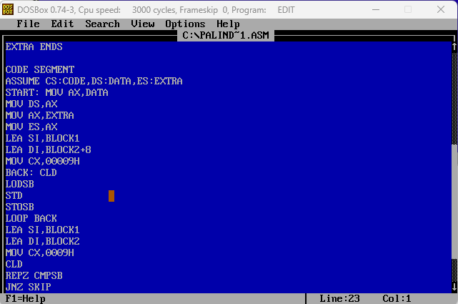

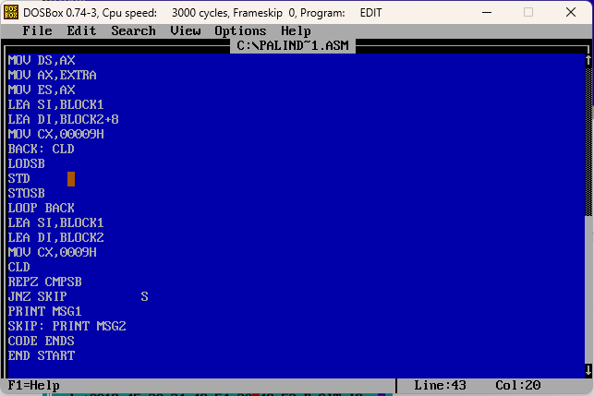

**Input1:**

**”MALAYALAM”**

**Output1:**

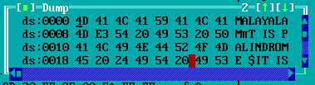

**Input2:**

**”SHASHWAT”**

**Output2:**

